SPRINT 4

|  |  |
| --- | --- |
| Date | 17 November 2022 |
| Team ID | PNT2022TMID18942 |
| Project Name | Hazardous Area Monitoring for Industrial Plant powered by IoT |

# WOKWI CODE:

#include <WiFi.h>//library for wifi #include <PubSubClient.h>//library for MQtt #include "DHT.h"// Library for dht11

#define DHTPIN 15 // what pin we're connected to #define DHTTYPE DHT22 // define type of sensor DHT 11 #define LED 2

DHT dht (DHTPIN, DHTTYPE);// creating the instance by passing pin and typr of dht connected void callback(char* subscribetopic, byte* payload, unsigned int payloadLength);

//-------credentials of IBM Accounts------

#define ORG "iagqzu"//IBM ORGANITION ID

#define DEVICE_TYPE "Deepak"//Device type mentioned in ibm watson IOT Platform #define DEVICE_ID "123"//Device ID mentioned in ibm watson IOT Platform #define TOKEN "12345678" //Token

String data3; float h, t;

//-------- Customise the above values -------- char server[] = ORG ".messaging.internetofthings.ibmcloud.com";// Server Name char publishTopic[]

= "iot-2/evt/Data/fmt/json";// topic name and type of event perform and format in which data to be send

char subscribetopic[] = "iot-2/cmd/command/fmt/String";// cmd REPRESENT command type AND COMMAND IS TEST OF FORMAT STRING

char authMethod[] = "use-token-auth";// authentication method char token[] = TOKEN; char clientId[] = "d:" ORG ":" DEVICE_TYPE ":" DEVICE_ID;//client id

// -

WiFiClient wifiClient; // creating the instance for wificlient

PubSubClient client(server, 1883, callback ,wifiClient); //calling the predefined client id by passing parameter like server id,portand wificredential

void setup()// configureing the ESP32

{

**Serial**.begin(115200); dht.begin();

pinMode(LED,OUTPUT); delay(10); **Serial**.println();

wificonnect(); mqttconnect();

} void loop()// Recursive Function

{ h = dht.readHumidity(); t = dht.readTemperature();

**Serial**.print("temp:"); **Serial**.println(t); **Serial**.print("Humid:"); **Serial**.println(h); PublishData(t, h);

delay(1000); if (!client.loop()) { mqttconnect();

}

}

/*.....................................retrieving to

Cloud. */

void PublishData(float temp, float humid)

{

mqttconnect();//function call for connecting to ibm

/* creating the String in in form JSon to update the data to ibm cloud */

String payload = "{\"temp\":"; payload += temp; payload += "," "\"Humid\":"; payload += humid; payload += "}";

**Serial**.print("Sending payload: ");

**Serial**.println(payload);

if (client.publish(publishTopic, (char*) payload.c_str())) {

**Serial**.println("Publish ok");// if it sucessfully upload data on the cloud then it will print publish ok in Serial monitor or else it will print publish failed } else

{

**Serial**.println("Publish failed");

}

}

void mqttconnect() { if (!client.connected()) {

**Serial**.print("Reconnecting client to ");

**Serial**.println(server);

while (!!!client.connect(clientId, authMethod, token)) {

**Serial**.print("."); delay(500);

}

initManagedDevice();

**Serial**.println();

} } void wificonnect() //function defination for wificonnect

{

**Serial**.println(); **Serial**.print("Connecting to ");

WiFi.begin("Wokwi-GUEST", "", 6);//passing the wifi credentials to establish the connection while (WiFi.status() != WL_CONNECTED) { delay(500);

**Serial**.print(".");

}

**Serial**.println(""); **Serial**.println("WiFi connected"); **Serial**.println("IP address: "); **Serial**.println(WiFi.localIP());

}

void initManagedDevice() {

if (client.subscribe(subscribetopic)) {

**Serial**.println((subscribetopic)); **Serial**.println("subscribe to cmd OK");

} else {

**Serial**.println("subscribe to cmd FAILED");

}

}

void callback(char* subscribetopic, byte* payload, unsigned int payloadLength)

{

**Serial**.print("callback invoked for topic: ");

**Serial**.println(subscribetopic);

for (int i = 0; i < payloadLength; i++) {

//Serial.print((char)payload[i]); data3

+= (char)payload[i];

}

**Serial**.println("data: "+ data3); if(data3=="lighton") { **Serial**.println(data3); digitalWrite(LED,HIGH); } else

{

**Serial**.println(data3); digitalWrite(LED,LOW);

} data3="";

}

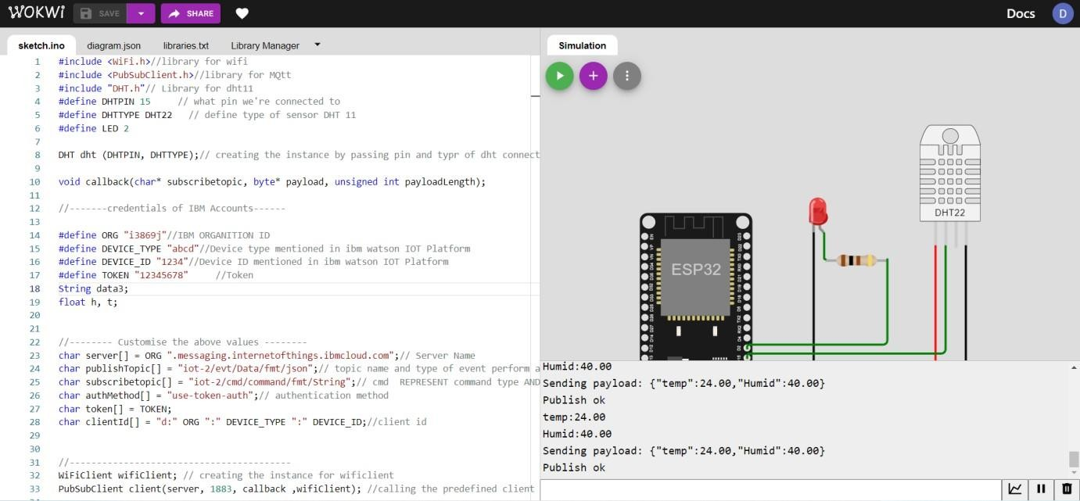

# WOKWI OUTPUT:

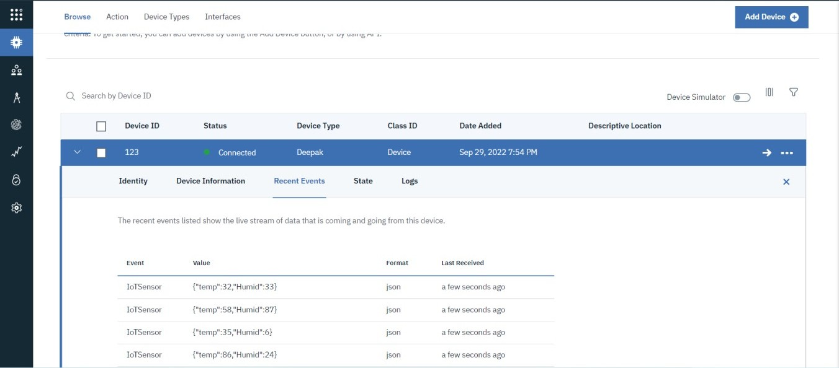**IBM WATSON PLATFORM DEVICE EVENT LOG:**

# DEVICE EVENT PAYLOAD:

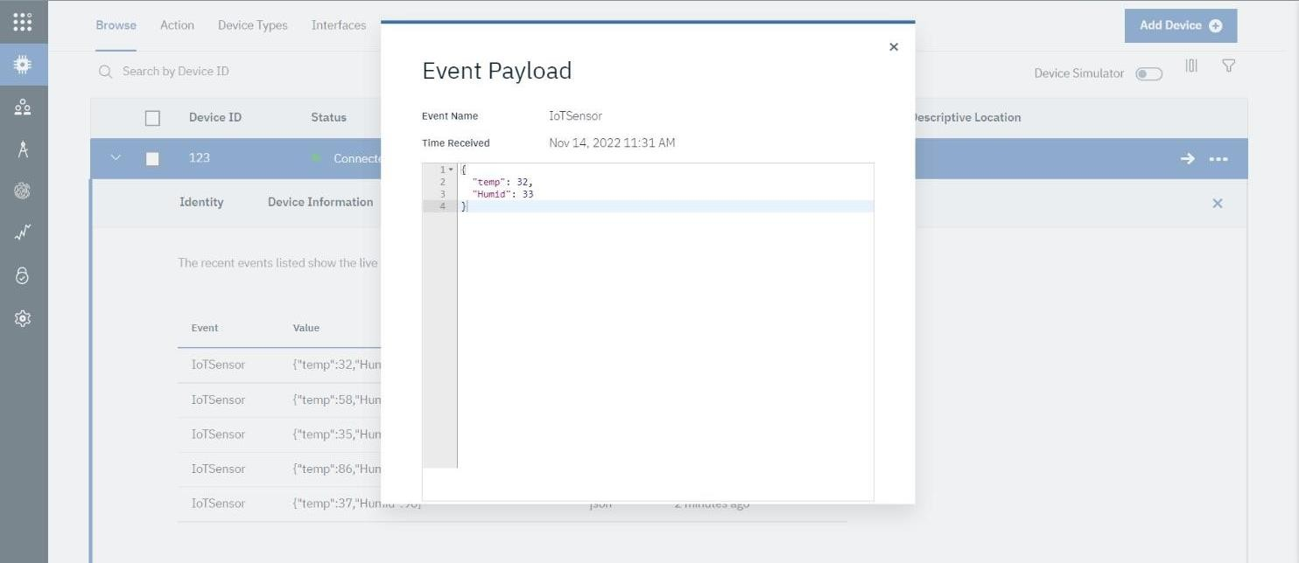

**DEVICE- BOARD:**

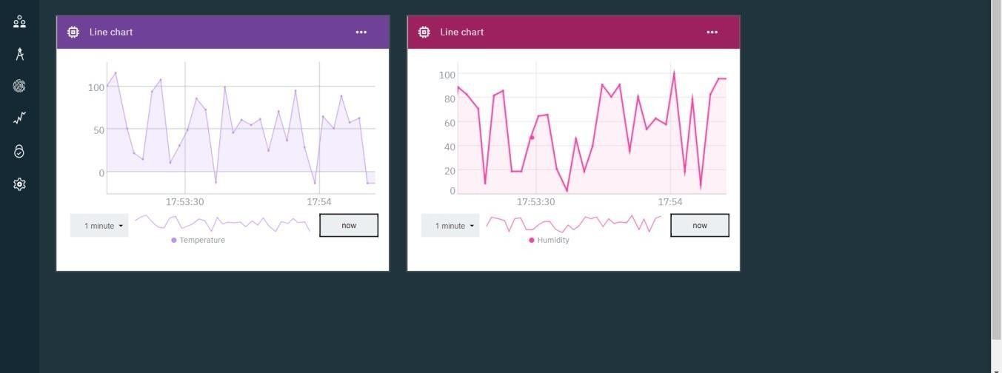

# IBM CLOUDANT DB LOG:

